**Title**

Title: ICT167 Assignment 2

Author: Lee Jihu

File name: ICT167 Assignment 2

**Requirement:**

Write a Java class called Student which can be used to represent the details of a Student together with some associated operations. The Student class will have the following information:

(a) Title of the student (eg, Mr, Miss, Ms, Mrs etc)

(b) A first name (given name)

(c) A last name (family name/surname)

(d) Student number (ID) – an integer number (of type long)

(e) A date of birth (in day/month/year format – three integers) - (Do NOT use the Date class from JAVA)

(f) There are three assignments, each marked out of a maximum of 100 marks and equally weighted. The marks for each assignment are recorded separately.

(g) There is weekly practical work. The marks for this component are recorded as a total mark obtained (out of a maximum of 20 marks) for all practical work demonstrated during the semester.

(h) There is one final examination that is marked out of a maximum of 100 marks and recorded separately.

(i) An overall mark (to be calculated within the program)

(j) A final grade, which is a string (to be calculated within the program)

The student class will have at least the following constructors and methods:

(i) two constructors - one without any parameters (the default constructor), and one with parameters to give initial values to instance variables.

(ii) a reasonable number of set and get methods.

(iii) input and output methods.

(iv) methods to compute the final overall mark and the final grade. These two methods will be

void methods that set the appropriate instance variables. Remember one method can call another method. If you prefer, you can define a single method that sets both the overall mark and the final string grade, but if you do this, use a helper method.

(v) an equals method which compares two student objects and returns true if they have the same student names, the same date of birth and the same student number, otherwise it returns false.

**User Guide:**

Open zip file named Assignment2ICT167 -> Open with netbeans named Client and Student-> Click Client and run the program.

**Structure**

The program is supposed to execute the requirements in the questionnaire, depending on the menu entered. All of the menu's execution programs are covered by the client class, and the data required to run this program is covered by the Student class. Also, the Student class requires different applications for each student type, which is treated as a separate class using the Super class. The menu is repeated until the user enters 1 (quit).

**Pseudo Code**

Set key to false

Set Student [] StudentPortfo to new Student[5]

Set statusinfo to 0

Set i to 0

Set count to 10

DOWHILE(!key)

Prompt menu

Read menu

IF(menu ==1)

Set key to true

ELSEIF (menu ==2) THEN

Prompt studentTitle, firName, lasName, studID, day, month, year, scoreAssign1, scoreAssign2, scoreAssign2, pracScore, finalScore,

Read and Save at Studentportfo[i]

i++

count—

ELSEIF (menu ==3) THEN

Set k to 0

DOWHILE(k<count)

Display StudnetPortfo[k]

k++

ENDWHILE

ELSEIF (menu==4) THEN

Set addup, aver =0

Set k=0

DOWHILE(k<count)

Addup = addup + StudentPortfo[k].readoverAll()

k++

ENDWHILE

Aver = addup/count

Display aver

ELSEIF (menu ==5) THEN

Set high, low, equal to 0

Set addup, aver to 0

Set k=0

DOWHILE(k<count)

Addup = addup + StudentPortfo[k].readoverAll()

k++

ENDWHILE

Aver = addup/count

Set k=0

DOWHILE(k<count)

IF (StudentPortfo[k].readoverAll()>aver) THEN

High++

ELSEIF(StudentPortfo[k].readoverAll()<aver)THEN

Low++

ELSE

Equal++

ENDIF

ENDIF

Display low,high,equal

ELSE IF (menu==6) THEN

Set found to false

Prompt ID

Read ID

Set k to 0

DOWHILE (k < count)

IF (StudentInfo[k].readstudID()==(ID)) THEN

DISPLAY StudentInfo[k]

Set find to true

k++

ENDIF

ENDWHILE

IF (! find) THEN

DISPLAY "no data"

ENDIF

ELSE IF (Menu ==7)

Set found to false

Set String LASTNAME, FIRSTNAME

Set k to 0

Prompt LASTNAME,FIRSTNAME

Read LASTNAME, FIRSTNAME

DOWHILE (k<count)

IF (StudentPortfo[k].readlasName()==(LASTNAME)&& StudentPortfo[k].readfirName()==(FIRSTNAME) THEN

DISPLAY StudentPortfo[k]

Set find to true

K++

ENDIF

ENDWHILE

IF(!found)

Display “No data”

ENDIF

ELSE IF (Menu == 8) THEN

Set TEMPROARY to new Student ()

Set k to 0

DOWHILE (k < count)

IF (StudentPortfo[k].readstudID() >

StudentPortfo[k+1].readstudID())

THEN

Set TEMPORARY to StudentPortfo[k];

Set StudentPortfo[k] to StudentPortfo[k+1]

Set StudentPortfo[k+1] to TEMPORARY

ENDIF

K++

ENDWHILE

Set j to 0

DOWHILE (j< count)

DISPLAY StudentPortfo[j]

j++

ENDWHILE

ELSE IF (Menu == 9) THEN

CREATE csv

END IF

ELSE

DISPLAY "INVALID MENU"

ENDIF

ENDWHILE

**Limitation**

I could not design a super class. Because of this, this code has troubles with setting the variables and getting the data. So, I used input method to make the code works at least. And this also made me to make this code available with only one kind of students (Course work students).

**TEST**

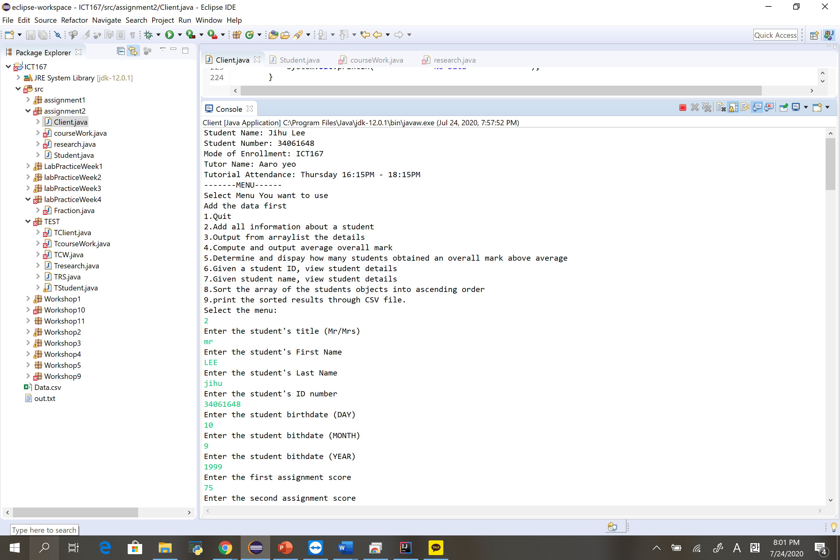

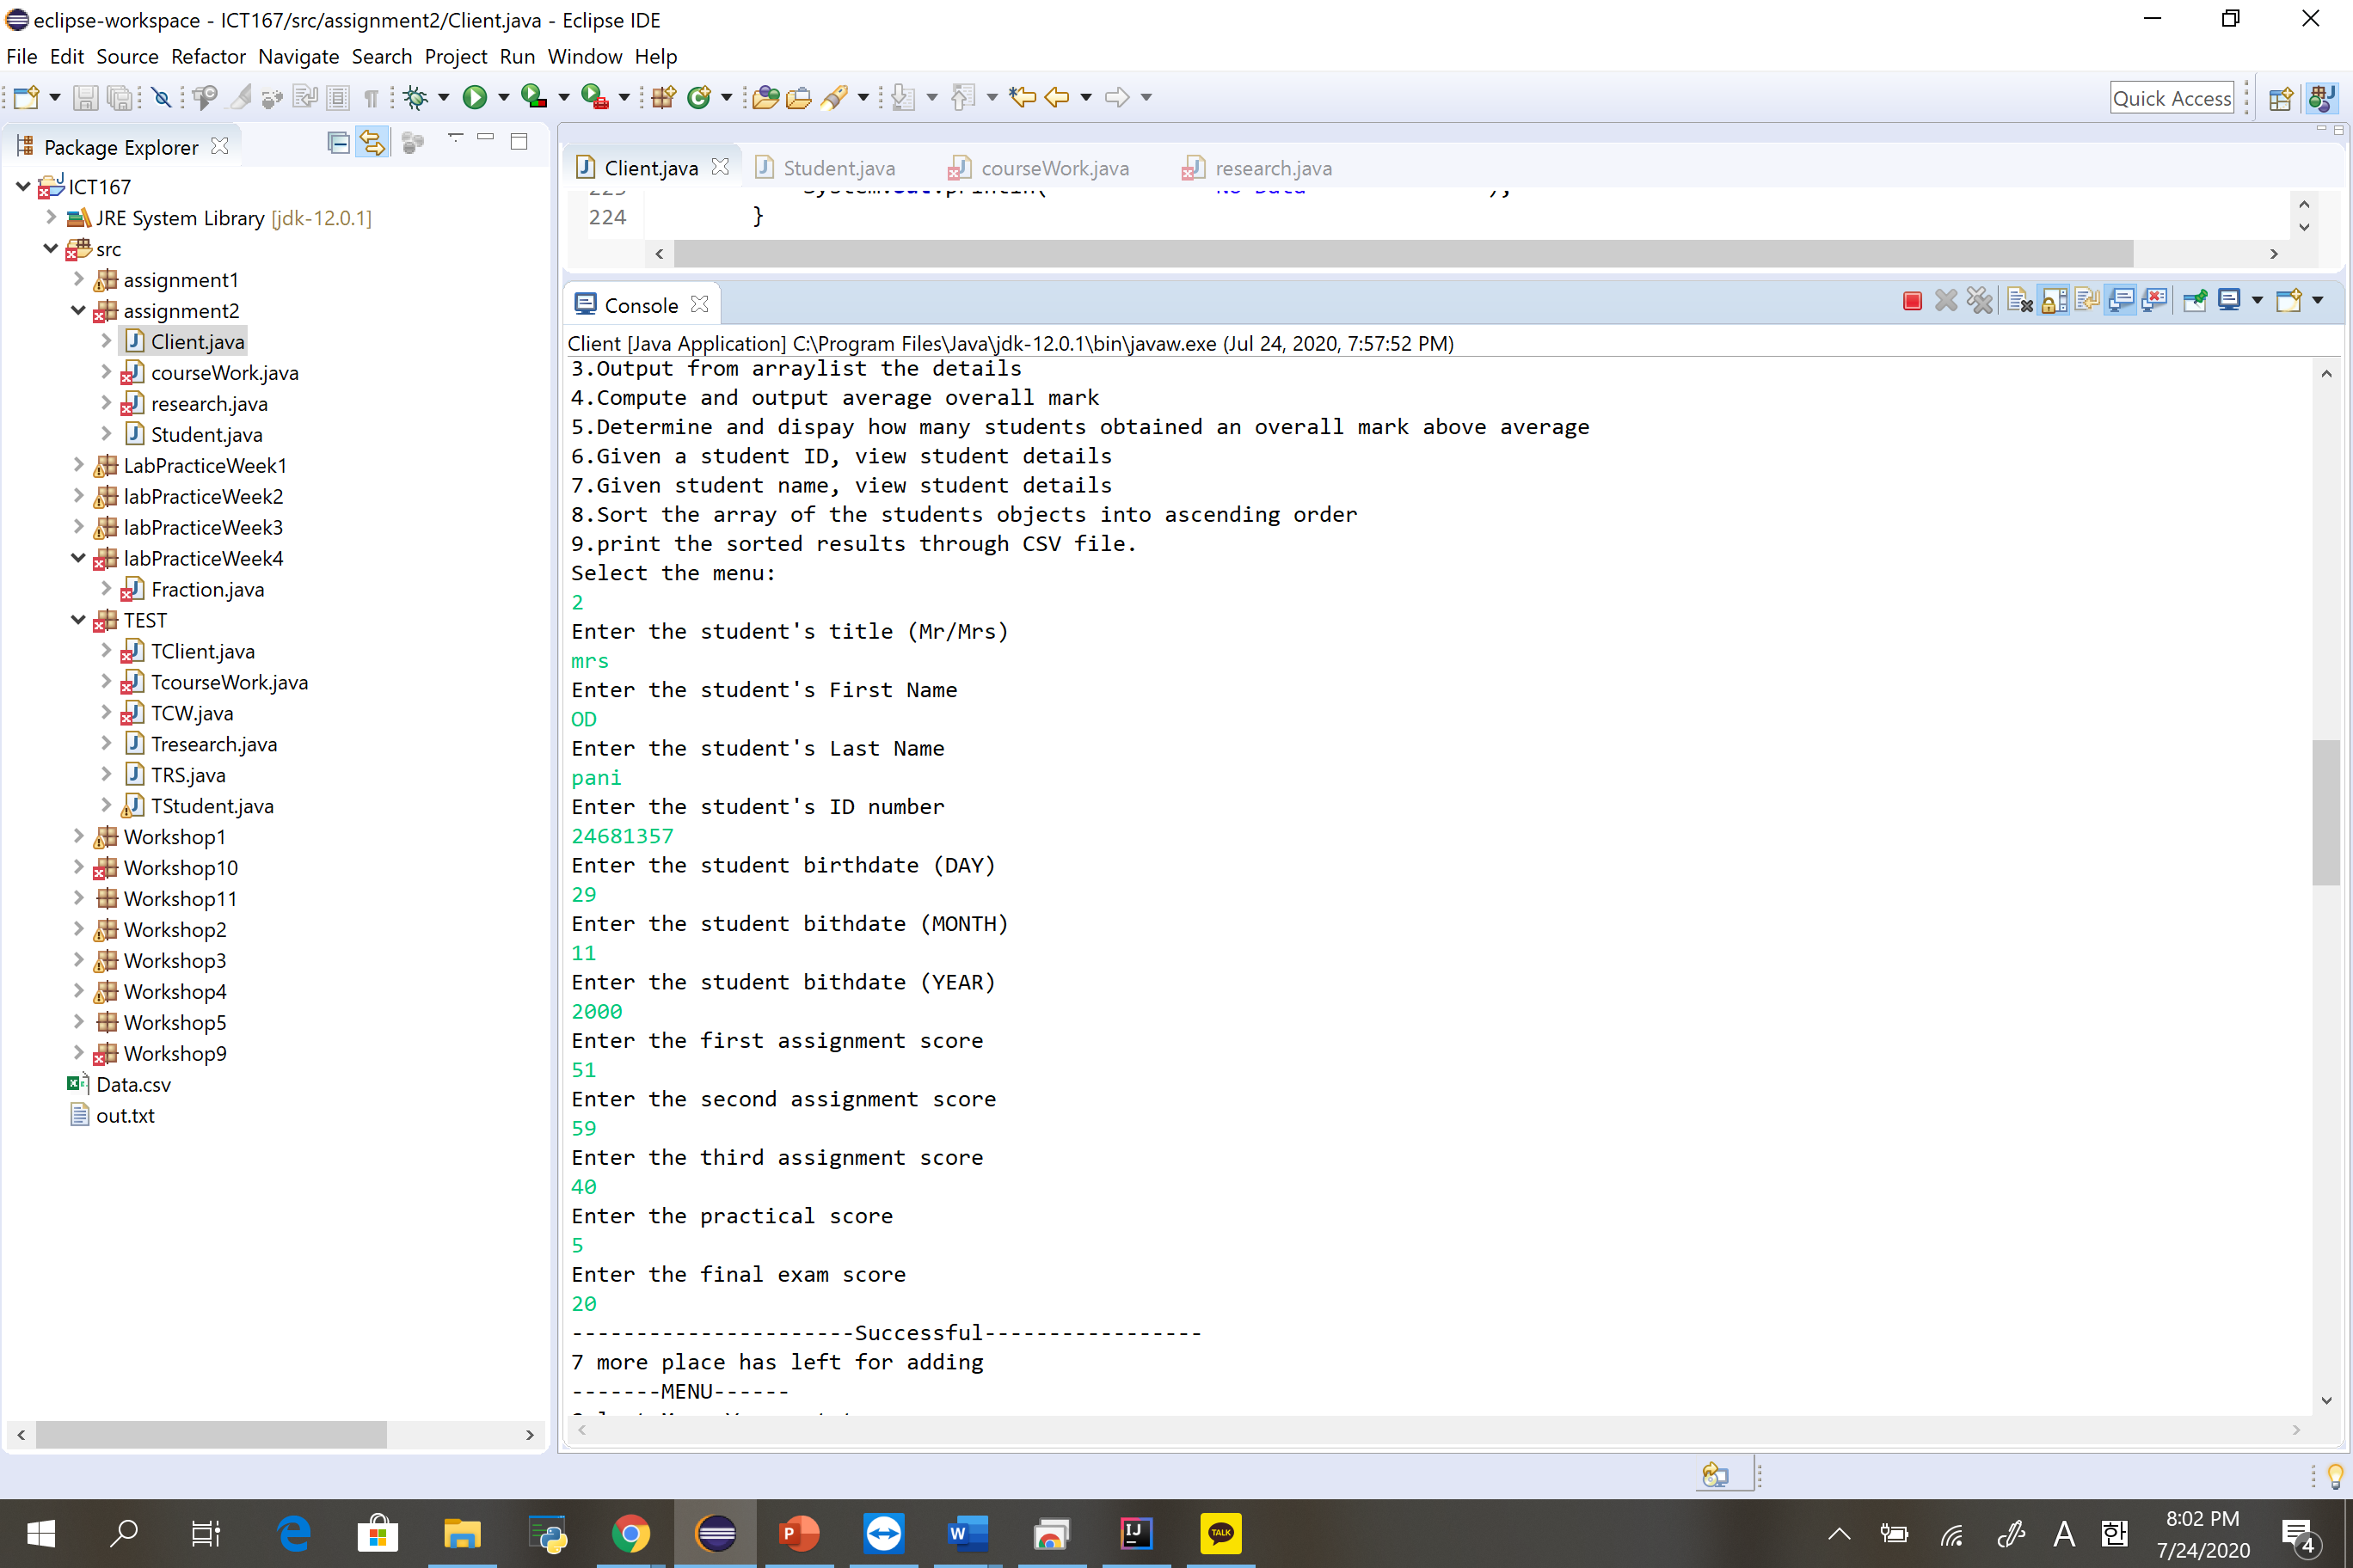

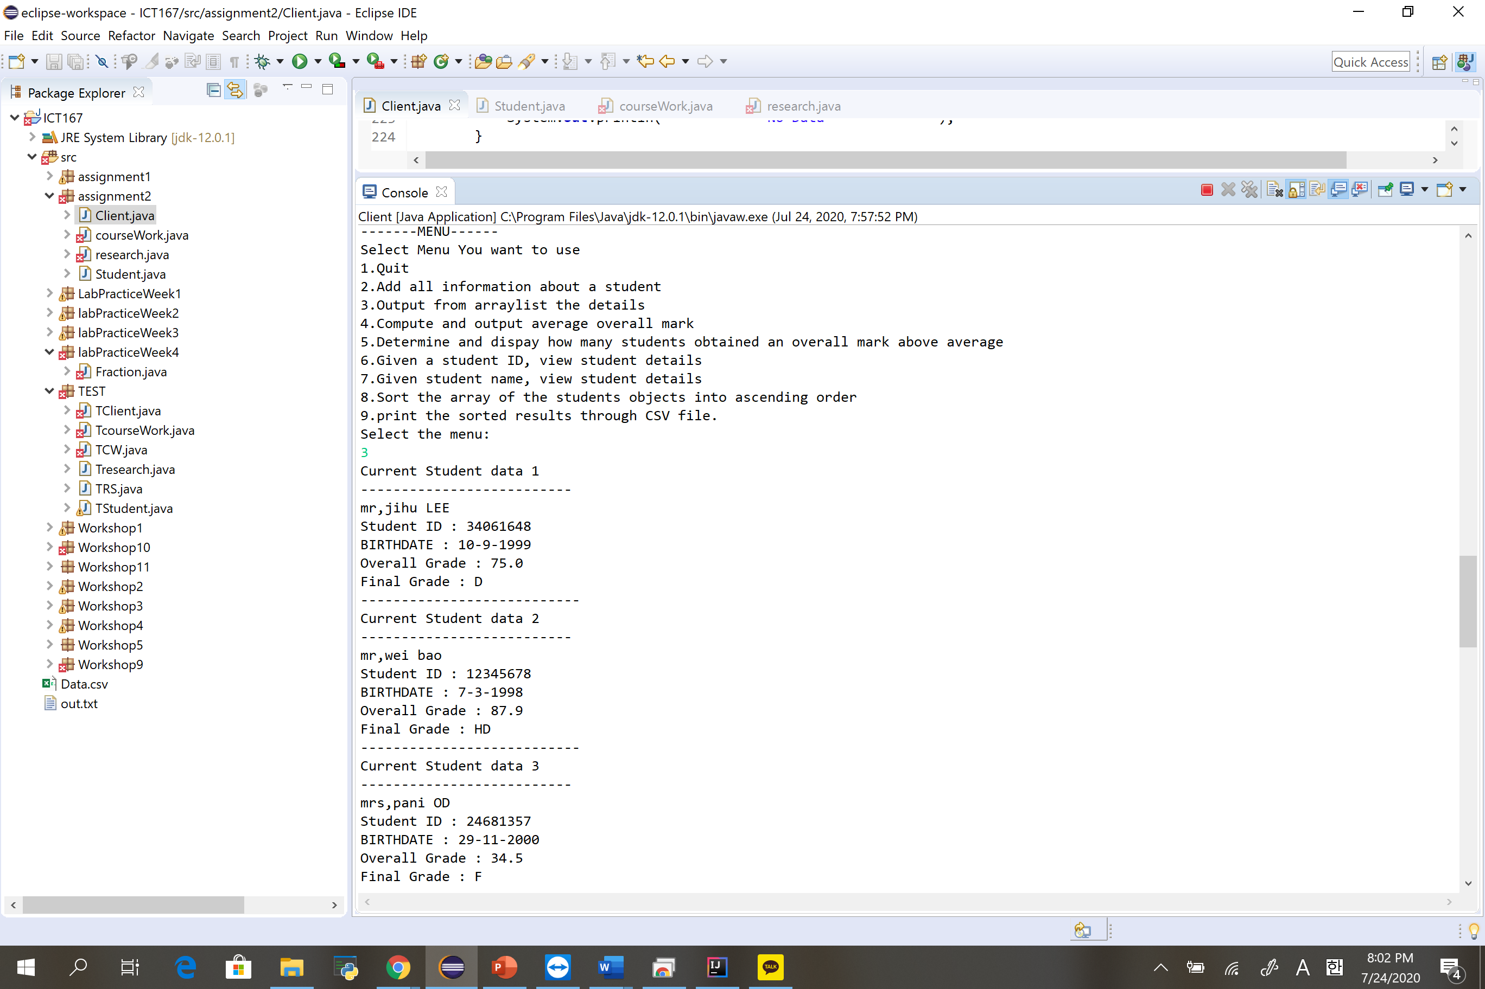

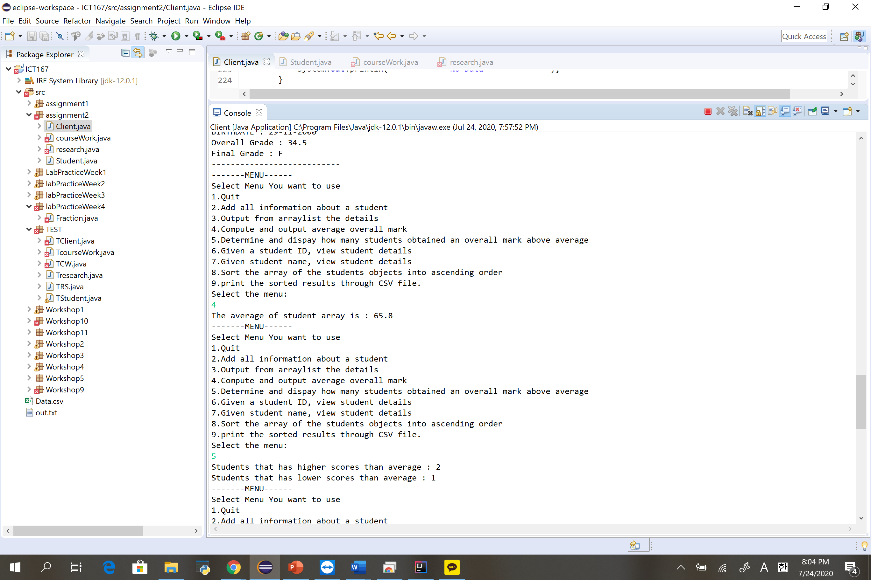

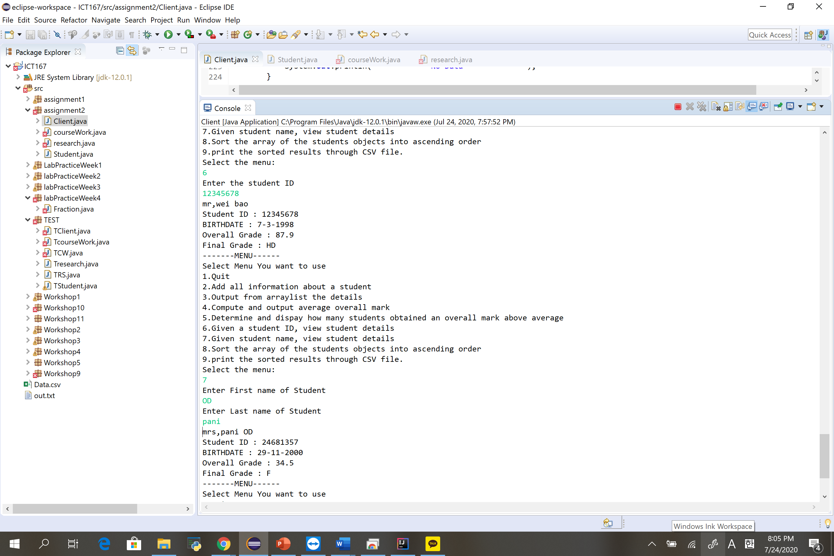

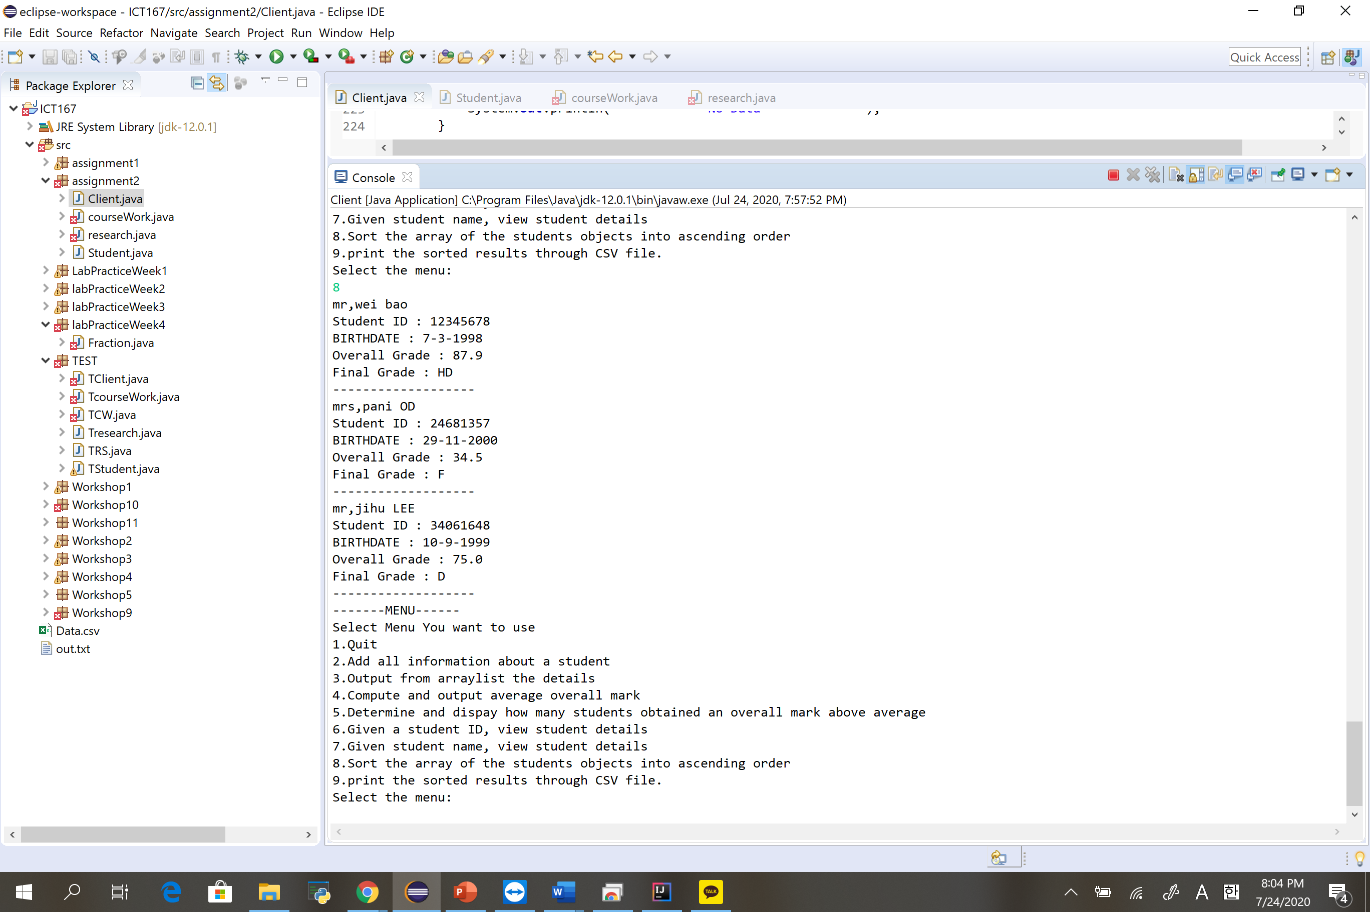

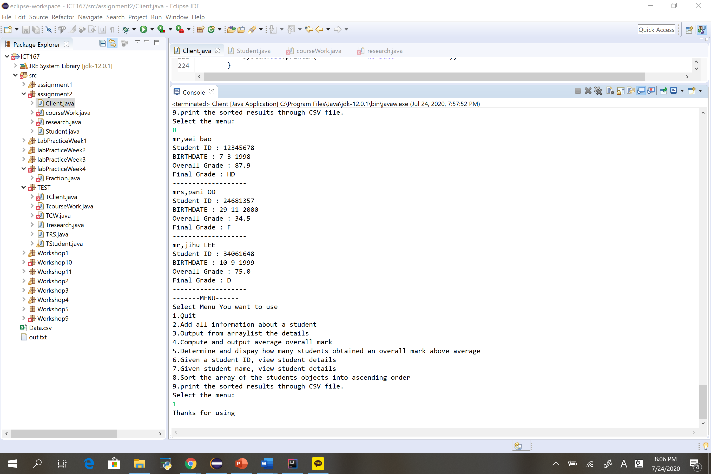

**Sorse code**

**Student**

**package** assignment2;

**import** java.util.Scanner;

**public** **class** Student

{

**private** String studentTitle;

**private** String firName;

**private** String lasName;

**private** **long** studID;

**private** **int** day;// in day/month/year format

**private** **int** month;

**private** **int** year;

**private** **int** scoreAssign1;

**private** **int** scoreAssign2;

**private** **int** scoreAssign3;

**private** **int** pracScore;

**private** **int** finalScore;

**private** **double** overAll;

**private** String finGrade;

**public** **static** Scanner *read*=**new** Scanner(System.***in***);

**public** **int** validAssignScore(**int** check)// this method is created for checking whether scores based on 100 is valid or not

{

**while** (check<0 || check>100)

{

System.***out***.println("Invalid Scores has been made");

System.***out***.println("Please Enter again");

check = *read*.nextInt();

}

**return** check;

}

**public** Student()

{

studentTitle = "Mr";

firName = "LEE";

lasName = "Jihu";

studID = 34061648;

day = 10;

month = 9;

year = 1999;

scoreAssign1 = 72;

scoreAssign2 = 75;

pracScore = 15;

finalScore = 74;

overAll = 0;

finGrade ="";

}

**public** Student(String newstudentTitle, String newfirName, String newlasName, **long** newstudID, **int** newday,**int** newmonth, **int** newyear, **int** newscoreAssign1, **int** newscoreAssign2, **int** newscoreAssign3, **int** newpracScore, **int** newfinalScore, **double** newoverAll, String newfinGrade)

{

studentTitle = newstudentTitle;

firName= newfirName;

lasName= newlasName;

studID= newstudID;

day = newday;

month = newmonth;

year = newyear;

scoreAssign1 = newscoreAssign1;

scoreAssign2 = newscoreAssign2;

scoreAssign3 = newscoreAssign3;

pracScore = newpracScore;

finalScore = newfinalScore;

overAll = newoverAll;

finGrade = newfinGrade;

}

**public** **void** checkFinalGrade()

{

**if** (overAll>=80)

{

finGrade = "HD";

}

**else** **if** (overAll>=70)

{

finGrade ="D";

}

**else** **if** (overAll>=60)

{

finGrade = "C";

}

**else** **if** (overAll>=50)

{

finGrade = "P";

}

**else**

{

finGrade = "F";

}

}

**public** **void** setStuTitle (String newstudentTitle)

{

studentTitle = newstudentTitle;

}

**public** **void** setfirName (String newfirName)

{

firName = newfirName;

}

**public** **void** setlasName (String newlasName)

{

lasName = newlasName;

}

**public** **void** setstudID (**long** newstudID)

{

studID= newstudID;

}

**public** **void** setday(**int** newday)

{

day = newday;

}

**public** **void** setmonth(**int** newmonth)

{

month = newmonth;

}

**public** **void** setyear (**int** newyear)

{

year = newyear;

}

**public** **void** setscoreAssign1(**int** newscoreAssign1)

{

scoreAssign1 = newscoreAssign1;

}

**public** **void** setscoreAssign2(**int** newscoreAssign2)

{

scoreAssign2 = newscoreAssign2;

}

**public** **void** setpracScore(**int** newpracScore)

{

pracScore = newpracScore;

}

**public** **void** setfinalScore (**int** newfinalScore)

{

finalScore = newfinalScore;

}

**private** **void** setoverAll()

{

overAll = scoreAssign1*0.15 + scoreAssign2*0.15 + scoreAssign3*0.15 + pracScore + finalScore*0.35;

}

/*public void SetupAll(String newstudentTitle, String newfirName, String newlasName, long newstudID, int newday,int newmonth, int newyear, int newscoreAssign1, int newscoreAssign2, int newpracScore, int newfinalScore, double newoverAll, String newfinGrade)

{

studentTitle = newstudentTitle;

firName= newfirName;

lasName= newlasName;

studID= newstudID;

day = newday;

month = newmonth;

year = newyear;

scoreAssign1 = newscoreAssign1;

scoreAssign2 = newscoreAssign2;

pracScore = newpracScore;

finalScore = newfinalScore;

overAll = newoverAll;

finGrade = newfinGrade;

}

*/

**public** **void** initiateDetailCWS()

{

System.***out***.println("Enter the student's title (Mr/Mrs)");

studentTitle = *read*.next();

System.***out***.println("Enter the student's First Name");

firName = *read*.next();

System.***out***.println("Enter the student's Last Name");

lasName = *read*.next();

System.***out***.println("Enter the student's ID number");

studID = *read*.nextLong();

System.***out***.println("Enter the student birthdate (DAY)");

day =*read*.nextInt();

System.***out***.println("Enter the student bithdate (MONTH)");

month = *read*.nextInt();

System.***out***.println("Enter the student bithdate (YEAR)");

year = *read*.nextInt();

System.***out***.println("Enter the first assignment score");

scoreAssign1 = *read*.nextInt();

scoreAssign1 = validAssignScore(scoreAssign1);

System.***out***.println("Enter the second assignment score");

scoreAssign2 = *read*.nextInt();

scoreAssign2 = validAssignScore(scoreAssign2);

System.***out***.println("Enter the third assignment score");

scoreAssign3 = *read*.nextInt();

scoreAssign3 = validAssignScore(scoreAssign3);

System.***out***.println("Enter the practical score");

pracScore = *read*.nextInt();

**while**(pracScore >20 || pracScore<0)

{

System.***out***.println("Invalid score has been made");

System.***out***.println("Please type again");

pracScore = *read*.nextInt();

}

System.***out***.println("Enter the final exam score");

finalScore = *read*.nextInt();

finalScore = validAssignScore(finalScore);

setoverAll();

checkFinalGrade();

}

**public** **void** printDetail()

{

System.***out***.println(studentTitle+","+lasName+" "+firName);

System.***out***.println("Student ID : "+studID);

System.***out***.println("BIRTHDATE : "+day+"-"+month+"-"+year);

System.***out***.println("Overall Grade : "+overAll);

System.***out***.println("Final Grade : "+finGrade);

}

**public** String printString()

{

**return** studentTitle+""+lasName+""+firName+""+studID+""+day+""+month+""+year+""+scoreAssign1+""+scoreAssign2+""+pracScore+""+finalScore+""+overAll+""+finGrade;

}

**public** **boolean** equalState(Student var)

{

**if**((var.lasName.equals(lasName))&&(var.firName.equals(firName))&&(var.day == day)&&(var.month == month)&&(var.year == year)&&(var.studID == studID))

{

**return** **true**;

}

**else**

{

**return** **false**;

}

}

**public** String readstudentTitle()

{

**return** studentTitle;

}

**public** String readfirName()

{

**return** firName;

}

**public** String readlasName()

{

**return** lasName;

}

**public** **long** readstudID()

{

**return** studID;

}

**public** **int** readday()

{

**return** day;

}

**public** **int** readmonth()

{

**return** month;

}

**public** **int** readyear()

{

**return** year;

}

**public** **int** readscoreAssign1()

{

**return** scoreAssign1;

}

**public** **int** readscoreAssign2()

{

**return** scoreAssign2;

}

**public** **int** readscoreAssign3()

{

**return** scoreAssign3;

}

**public** **int** readpracScore()

{

**return** pracScore;

}

**public** **int** readfinalScore()

{

**return** finalScore;

}

**public** **double** readoverAll()

{

**return** overAll;

}

**public** String readfinGrade()

{

**return** finGrade;

}

**public** String nameFull()

{

**return** studentTitle+","+firName+" "+lasName;

}

}

**Client**

**package** assignment2;

**import** java.util.Scanner;

**public** **class** Client

{

**public** **static** Scanner *read* = **new** Scanner(System.***in***);

**public** **static** **void** main(String[] args)

{

*studentInfo*();

*menuSelect*();

}

**public** **static** **void** menuSelect()

{

**boolean** equalState = **false**;

**boolean** key = **false**;

**while**(!key)

{

**int** menu;

System.***out***.println("-------MENU------");

System.***out***.println("Select Menu You want to use");

**if**(!equalState)

{

System.***out***.println("Add the data first");

}

System.***out***.println("1.Quit");

System.***out***.println("2.Add all information about a student");

System.***out***.println("3.Output from arraylist the details");

System.***out***.println("4.Compute and output average overall mark");

System.***out***.println("5.Determine and dispay how many students obtained an overall mark above average");

System.***out***.println("6.Given a student ID, view student details");

System.***out***.println("7.Given student name, view student details");

System.***out***.println("8.Sort the array of the students objects into ascending order");

System.***out***.println("9.print the sorted results through CSV file.");

System.***out***.println("Select the menu: ");

menu = *read*.nextInt();

**if**(menu<12)

{

**if**(menu==1)

{

key = **true**;

System.***out***.println("Thanks for using");

}

**else** **if**(menu ==2)

{

*menu2*();

equalState = **true**;

}

**if**((menu==3) &&(equalState))

{

*menu3*();

}

**else** **if**((menu==4) &&(equalState))

{

*menu4*();

}

**else** **if**((menu==5) &&(equalState))

{

*menu5*();

}

**else** **if**((menu==6) &&(equalState))

{

*menu6*();

}

**else** **if**((menu==7) &&(equalState))

{

*menu7*();

}

**else** **if**((menu==8) &&(equalState))

{

*menu8*();

}

**else** **if**((menu==9) &&(equalState))

{

*menu9*();

}

}

**else**

{

System.***out***.println("Invalid keyword");

}

}

}

**public** **static** Student [] *StudentPortfo* = **new** Student[10];

**public** **static** **int** *statusinfo* =0;

**public** **static** **int** *count* =10;

**public** **static** **void** studentInfo()

{

System.***out***.println("Student Name: Jihu Lee");

System.***out***.println("Student Number: 34061648");

System.***out***.println("Mode of Enrollment: ICT167");

System.***out***.println("Tutor Name: Aaro yeo ");

System.***out***.println("Tutorial Attendance: Thursday 16:15PM - 18:15PM");

}

**public** **static** **void** menu2()

{

*StudentPortfo* [*statusinfo*]= **new** Student();

*StudentPortfo* [*statusinfo*].initiateDetailCWS();

*count*--;

**for** (**int** i=0; i<*statusinfo*; i++)

{

**if**(*StudentPortfo*[*statusinfo*].equalState(*StudentPortfo*[i]))

{

**while**(*StudentPortfo*[*statusinfo*].equalState(*StudentPortfo*[i]))

{

System.***out***.println("Data has been made already, Please try again");

*StudentPortfo*[*statusinfo*].initiateDetailCWS();

}

}

}

System.***out***.println("----------------------Successful-----------------");

**if**(*count*==0)

{

System.***out***.println("----------------End of storage-------------");

}

**else**

{

System.***out***.println(*count*+" more place has left for adding");

}

*statusinfo*++;

}

**public** **static** **void** menu3()

{

**for** (**int** i=0; i<*statusinfo*; i++)

{

System.***out***.println("Current Student data "+(i+1));

System.***out***.println("--------------------------");

*StudentPortfo*[i].printDetail();

System.***out***.println("---------------------------");

}

}

**public** **static** **void** menu4()

{

**double** addup =0;

**double** aver ;

**for**(**int** i=0; i<*statusinfo*; i++)

{

addup = addup + *StudentPortfo*[i].readoverAll();

}

aver = addup/*statusinfo*;

System.***out***.println("The average of student array is : "+aver);

}

**public** **static** **void** menu5()

{

**double** addup =0;

**double** aver;

**int** high=0,low=0;

**for**(**int** i=0; i<*statusinfo*; i++)

{

addup = addup + *StudentPortfo*[i].readoverAll();

}

aver = addup/*statusinfo*;

**for** (**int** i=0; i<*statusinfo*; i++)

{

**if**(*StudentPortfo*[i].readoverAll()>aver)

{

high++;

}

**else** **if**(*StudentPortfo*[i].readoverAll()<aver)

{

low++;

}

}

System.***out***.println("Students that has higher scores than average : "+high);

System.***out***.println("Students that has lower scores than average : "+low);

}

**public** **static** **void** menu6()

{

**boolean** found = **false**;

**int** id;

System.***out***.println("Enter the student ID");

id = *read*.nextInt();

**for**(**int** i=0; i<*statusinfo*; i++)

{

**if**(*StudentPortfo*[i].readstudID()==id)

{

*StudentPortfo*[i].printDetail();

found =**true**;

}

}

**if**(!found)

{

System.***out***.println("-----------No Data-----------");

}

}

**public** **static** **void** menu7()

{

**boolean** found = **false**;

String LASTNAME,FIRSTNAME;

System.***out***.println("Enter First name of Student");

FIRSTNAME = *read*.next();

System.***out***.println("Enter Last name of Student");

LASTNAME = *read*.next();

**for**(**int** i=0; i<*statusinfo*; i++)

{

**if**((*StudentPortfo*[i].readfirName().equalsIgnoreCase(FIRSTNAME)) &&(*StudentPortfo*[i].readlasName().equalsIgnoreCase(LASTNAME)))

{

*StudentPortfo*[i].printDetail();

found = **true**;

}

}

**if**(!found)

{

System.***out***.println("------------No Data ------------");

}

}

**public** **static** **void** menu8()

{

Student TEMPORARY = **new** Student();

**for** (**int** i=1; i<*statusinfo*; i++)

{

**for** (**int** j=0; j<*statusinfo*-1; j++)

{

**if**(*StudentPortfo*[j].readstudID() > *StudentPortfo*[j+1].readstudID())

{

TEMPORARY = *StudentPortfo*[j];

*StudentPortfo* [j]= *StudentPortfo*[j+1];

*StudentPortfo* [j+1] = TEMPORARY;

}

}

}

**for** (**int** i=0; i<*statusinfo*; i++)

{

*StudentPortfo*[i].printDetail();

System.***out***.println("-------------------");

}

}

**public** **static** **void** menu9()

{

System.***out***.println("create CSV");

}

}

**corseWork**

**package** assignment2;

**public** **class** courseWork **extends** Student

{

**private** **int** scoreAssign1;

**private** **int** scoreAssign2;

**private** **int** scoreAssign3;

**private** **int** pracScore;

**private** **int** finalScore;

**private** **double** overAll;

**private** String finGrade;

**public** Child(String StudTitle, String FirstName, String LastName,**long** studID)

{

**super**(StudTitle,FirstName,LastName,studID,"CW");

}

//overAll = scoreAssign1*0.15 + scoreAssign2*0.15 + scoreAssign3*0.15 + pracScore + finalScore*0.35;

}

**Reserch**

**package** assignment2;

**public** **class** research **extends** Student

{

**private** **int** proposal;

**private** **int** presentation;

**private** **int** finalScore;

**private** **double** overAll;

**private** String finGrade;

**public** Adult(String StudTitle, String FirstName, String LastName,**long** studID) {

**super**(StudTitle,FirstName,LastName,studID,"RS");

}

//overAll = proposal*0.3 + presentation*0.2 + finalScore*0.5;

}